Class component vs function component
What is hooks
UseMemo, useCallback and useEffect diff
Synthetic event
API fetch data - React code
Redux
HOC
VDom
Optimisation techniques
JavaScript : Closure, Hoisting
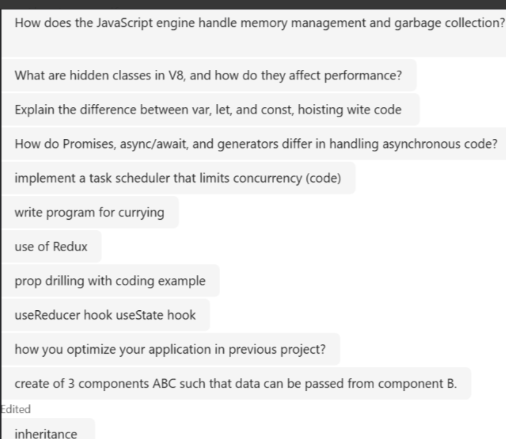

**HTML
=======
Right or wrong code?
<h1>Title</h1>
<div>
<div>Content <p> I am here </p> more content</div>
</div>

Semantic elements?
Diff between Div. and span?
How to center Div.?
HTML import elements?
**CSS
====
Flex box model? use?
How achieve responsive application using HTML/CSS?
What is use Media Query?
Diff between class and selector?
Visibility none and display none?
Property | Behavior
display: none | Completely removes the element from the layout. No space is reserved.
visibility: hidden | Hides the element visually but still reserves space in the layout.

**JavaScript
=========
Datatypes?
Diff Null and Undefine?
Callback function?
Diff between Var and Let?
What is Hoisting?
set Timeout?
promise in JavaScript?
prototypes in JavaScript?

**React
=====
Class component and Function Component?
Virtual Dom?
JSX?
Synthetic event?
How do debug?
HOC?
How make responsive application using react?
Hooks?
Diff between useEffect & useMemo?
what is Redux? Action, reducer, store?
How can be state update in Redux?

- Difference between promises and async/await
- What is block scope and local scope
- Is javascript single threading or multi threading
- Print first n Fibonacci series
Ans: function printfibonacci(n){
let a=0, b=1;
let result=[];
for (let i=0;i<n;i++){
result.push(a);
[a,b]=[b,a+b];
}
console.log("fibonacci series"+ result);
}
printfibonacci(5)

- Find second max no. of occurrences of character in an array
- Is React unidirectional or bidirectional?
- User captures data in tabs , how do we get it in final submission page?
- What is prototype?
- How does another function takes properties of main function?
- What is event loop?

- O/p of this - setTimeout(()=> {
console.log("Hello");
}, 0);
console.log("World");
Ans: World
Hello
- How does function dog and cat inherit properties from animal?
Ans: inheritance works in JavaScript using prototypes.
class Animal {
constructor(name) {
this.name = name;
}
speak() {
console.log(`${this.name} makes a sound.`);
}
}
class Dog extends Animal {
speak() {
console.log(`${this.name} barks.`);
}
}
class Cat extends Animal {
speak() {
console.log(`${this.name} meows.`);
}
}
const dog = new Dog("Rex");
const cat = new Cat("Whiskers");
dog.speak(); // Rex barks.
cat.speak(); // Whiskers meows.

- <style>
P { color: red; }
P { color: blue !important; }
P { color: green; }
</style>
<p style=”color: orange”>my test is red</p>
Ans: my test is red – printed in blue, because it overrides all styles.
- <style>
.first {background: red;}
.third {background: green;}
.second {background: blue;}

#surname {background: yellow;}
.fourth {background: pink;}
</style>

<body>
<label class=”third second first”>Name</label>
<label id=”surname” class=”fourth”>Surname</label>
</body>

Ans: The label has three classes: third, second, and first. All three classes define a background color. However, the order in which the classes appear in the HTML does not determine which style is applied.
Instead, CSS applies styles based on:
- Specificity – All three are class selectors, so they have equal specificity.
- Cascade Order – When specificity is equal, the last rule defined in the CSS wins.
🧠 CSS Rule Order:
- .first → red
- .third → green
- .second → blue ← ✅ Last defined
🎨 Therefore, the background color of the label will be blue.

